**BASIC MULTIVARIABLE CALCULUS**

**Introduction**

* We apply **partial derivatives** to solve functions which depend on **multiple** variables.
* Like **area of rectangle** is ***l*b***.

**Limit of a Two Variable Function**

* Objective of studying ***limits*** is to understand **how functions behave** when its variables approach a **certain point**.



If ***limit*** obtained is **undefined**:-

* We use **path methods** for making **undefined** forms representable.
* Applicable when ***x -> 0*** and ***y -> 0***.

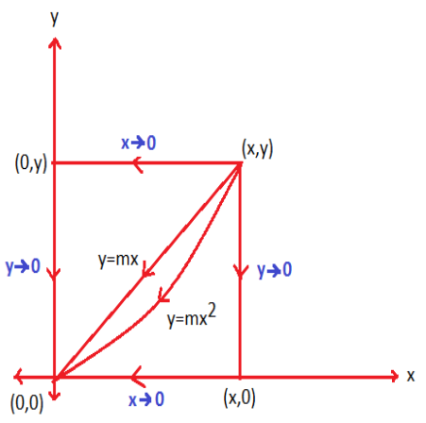

**Path 1:**

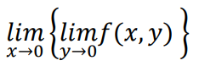

**Path 2:**

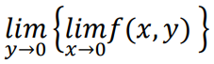

***\*If Path 1 & 2 are same, then proceed.***

***Else limit doesn’t exist\****

**Path 3:**

**Put *mx* in place of all *y* in equation.**

**And *limit* of whole equation must be *x -> 0*.**

***\*If Path 1,2 & 3 are same, then proceed.***

***Else limit doesn’t exist\****

**Path 4:**

**Put *mx2* in place of all *y* in equation.**

**And *limit* of whole equation must be *x -> 0*.**

**Continuity of Two Variable Functions**

**A function f(x,y) is continuous at the point f(x0,y0), if:**

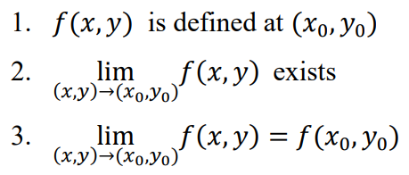

* We use **path methods** to test the **continuity**.
* If the ***limit*** is revealed to **not** exist, then the function is declared **discontinuous**.
* Also, the **value** at a given point in problem must **match** when put in equation.

**For example:**

**Given function:**

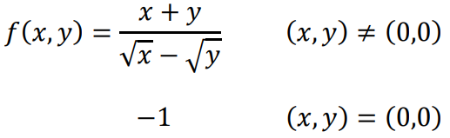

**After applying path methods, values for all paths are same.**

**Thus, the *limit* exists.**

**But,**

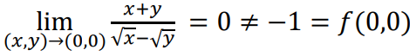

**Therefore, the function is discontinuous at (0,0).**

**Partial Derivatives**

**With respect to x:**

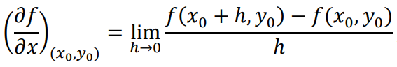

**With respect to y:**

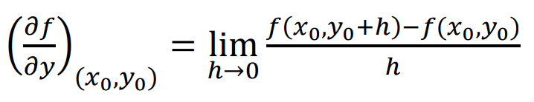

**There can be more variables in it, but pattern remains the same.**

**For example:**



**Solution:**

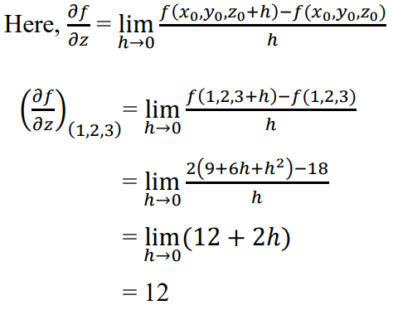

**Second Order Partial Derivative**

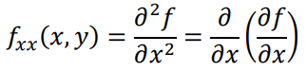 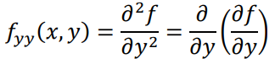

**The alternate variable is placed as *constant*, in both cases.**

**Mixed Order Partial Derivative**

* Are type of **second order partial derivative**.

** **

**Differentiation is done from right side (first w.r.t. x & then w.r.t. y).**

**Clairaut’s Theorem**

**fxy (x,y) = fyx (x,y)**

**Homogeneous Function**

* A function in which **degree** of all terms are **same**.



**Euler’s Theorem**

* Applicable on ***homogeneous* functions** only.

**n below is *common degree* among terms**

**And,**

**u = f(x,y)**

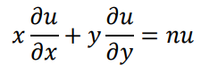

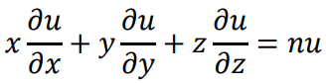

***Correlation 1:***

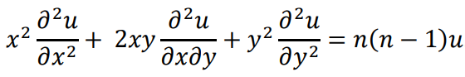

***Correlation 2:***

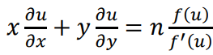

***Correlation 3:***

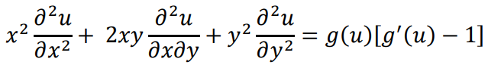

**Where,**



**For example:**

**Given equation:**



**Replacing x with tx & y with ty,**

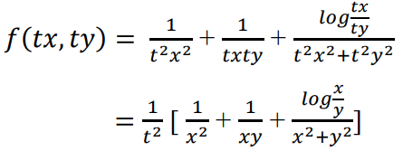



**Hence, the degree of the function is -2.**

**Chain Rule**

Function of two independent variables:-

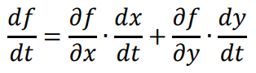

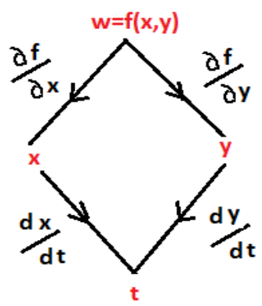

Function of three independent variables:-

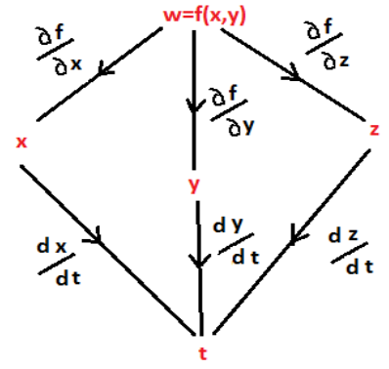

Function in Functions:-

**w = f(x,y,z)**

**x = g(r,s)**

**y = h(r,s)**

**z = k(r,s)**

**w has x,y,z in it & x,y,z each have r,s in them.**

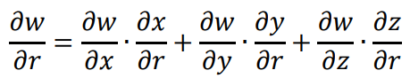

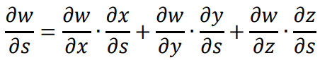

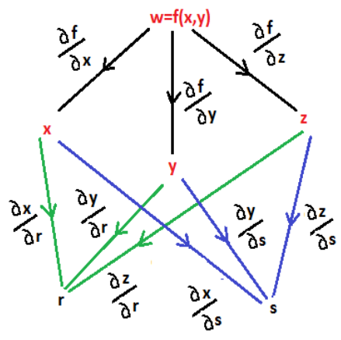

**Implicit Differentiation**

**For a multivariable function f,**

**f(x,y) = 0**

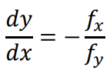

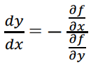

**Jacobian**

For two independent variables:-

**u and v are functions.**

**And these functions contain variable x and y in them.**

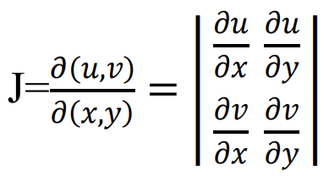

For three independent variables:-

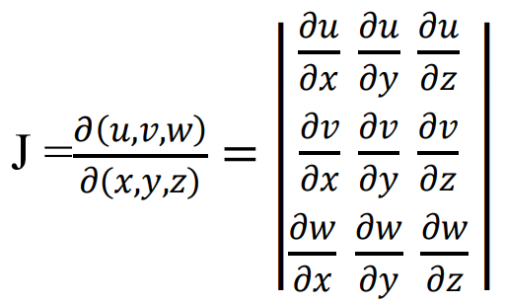

**Jacobian Properties**

**Property 1:**

**J.J' = 1**

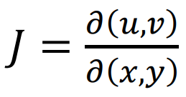 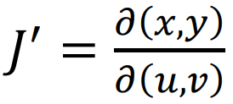

**Property 2:**

**If function u and v contain independent variables r and s.**

**And r and s are functions of x and y.**

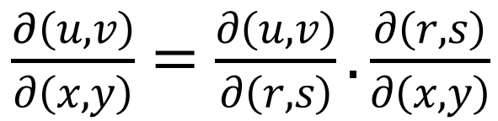

**Partial Derivative Applications**

* Finding how a **3D curve** changes gradually.
* For example, a **2D curve** can have **only one tangent** for a given point.
* But in **3D curve**, there are **infinite** possibilities of tangent lines.
* And **only one** tangent plane.

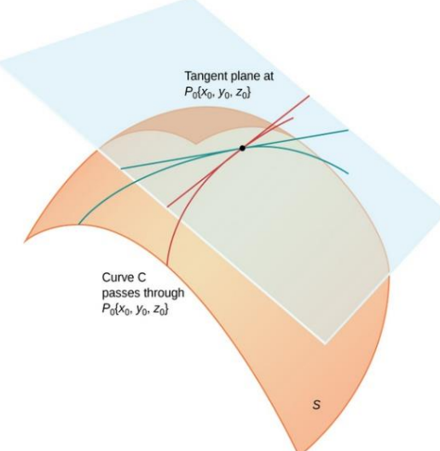

**Tangent plane:**



**f is the tangent plane.**

**Normal line to tangent plane:**

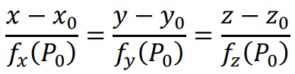

**Example:**

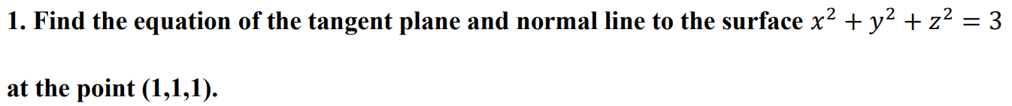



**Equation of tangent plane:**

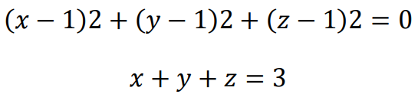

**Equation of normal line:**

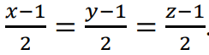

**Local Maximum & Minimum**

* **Local minimum:** A point on a region which is relatively on a **lower position** than one or more points.
* **Local maximum:** A point on a region which is relatively on a **higher position** than one or more points.
* **Global minimum:** A point on a region which on the **lowest position** than rest of the points.
* **Global minimum:** A point on a region which on the **highest position** than rest of the points.

For two-dimensional planes (open disk):-

**Local maxima:**

**f(x,y) >= f(a,b)**

**Local minima:**

**f(x,y) <= f(a,b)**

**Second Derivative Test for Local Extreme Values**

**Assume that:**

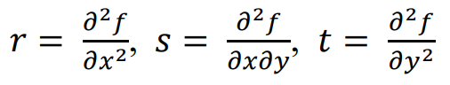

**If:**

**fx(a,b) = fy(a,b) = 0**

**Then:**

**f has a local maximum at (a, b) if r < 0 and rt – s2 > 0 at (a, b)**

**f has a local minimum at (a, b) if r > 0 and rt – s2 > 0 at (a, b)**

**f has a saddle point at (a, b) if rt – s2 < 0 at (a, b)**

**The test has no conclusion at (a, b) if rt – s2 = 0 at (a, b).**

* **Saddle point:** Point in graph where the graph starts changing from ***concave upward*** to ***concave downward***, or **vice-versa**.
* **Concave upward curve:** Curve rising **up** in a graph.
* **Local extrema:** Local minima or local maxima.

**Lagrange Multipliers**

* Used for finding ***maxima*** and ***minima***, but under certain **constraints**.
* Widely used for **optimization** purposes.
* In this one function serves as a **constraint** to our **main function**.
* Used for any number of **independent variables**, we are using **three** for tutorial.
* ***Lagrange multiplier*** is denoted by **λ**.

**Let:**

**Main function: f = f(x,y,z)**

**Constraint: g = g(x,y,z) = 0**

**Steps:**

**Step 1: Make an equation of *f + λg = 0***

**Step 2: *Partially differentiate* that equation for all the given number of variables separately.**

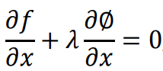 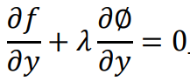 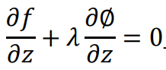

**Step 3: Eliminate λ from all the equations & get x,y,z.**

**Step 4: Substitute values of x,y,z into function f to get *minimum* & *maximum* values.**

**For example:**



**λ (lambda):**

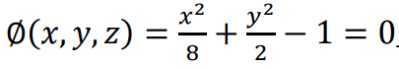

**After calculation:**

** **

**Four extreme points on ellipse:**



**Taylor’s Formula**

* Used for representing a **function** in form of **polynomial pattern**.
* Applied for many purposes including **error analysis**.

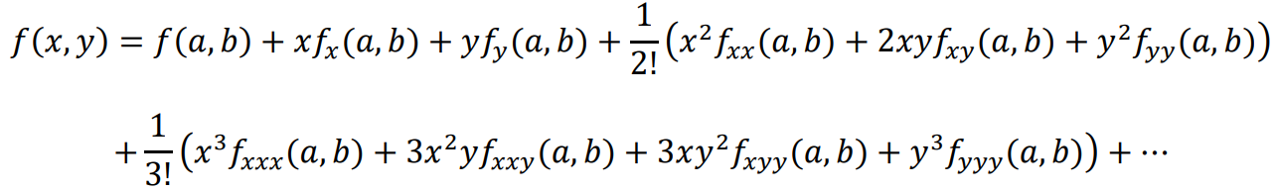

**The expansion depends on the degree of the equation.**

**For example:**



**Means that:**

**(x – 1) = 0**

**=> x = 1 = a**

**(y + 2) = 0**

**=> y = -2 = b**

**Maclaurin’s Series**

***\*Same as Taylor’s series, but (a,b) are fixed at origin (0,0)\****